Instructions for downloading GM350 software

1. Click on 09/04/2010 13.1MB to download the software

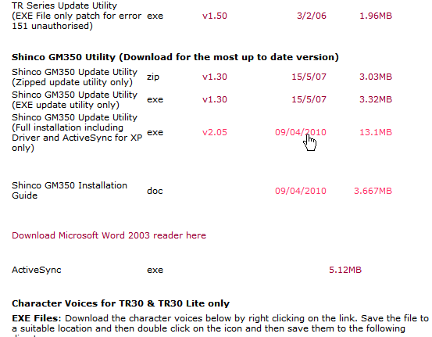

2. Click on Save
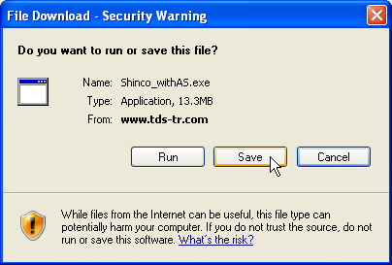

3. Double Click on My Documents
NOTE: DO NOT SAVE TO YOUR DESKTOP 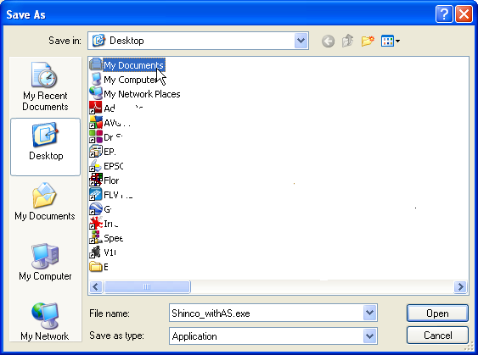

Click on Save
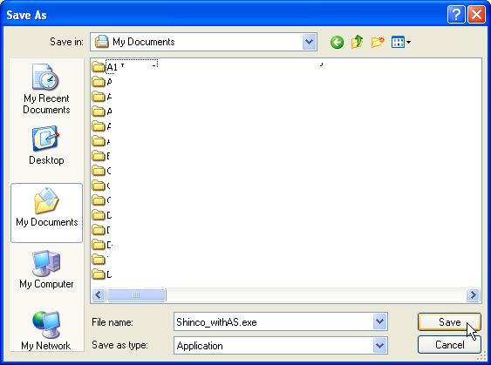
File will download to My Documents, Please wait it may take a few minutes.
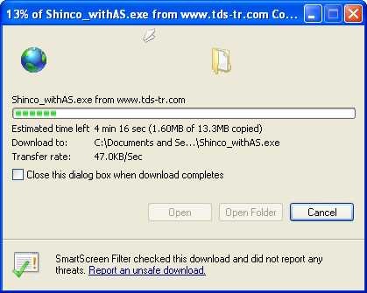
Click on Run
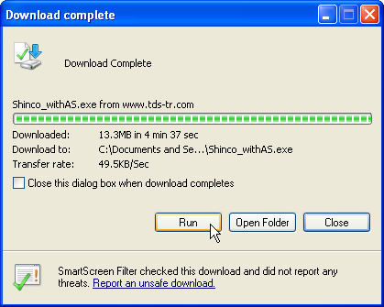
Click on Run again Note if you do not run, the program will not install
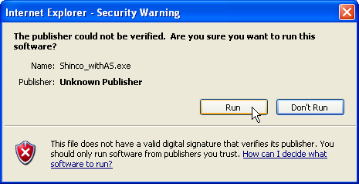
Click on Extract

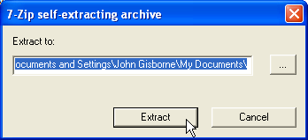

File will self extract to your My Documents Folder

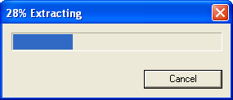

Look in your My Documents folder for the folder named “ Shinco_withAS”

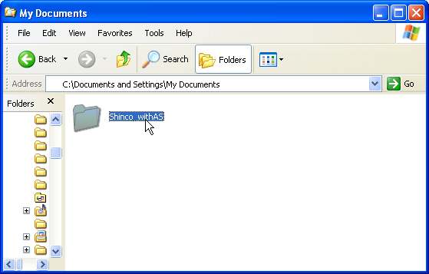

Double Click on Shinco_withAS to open it.
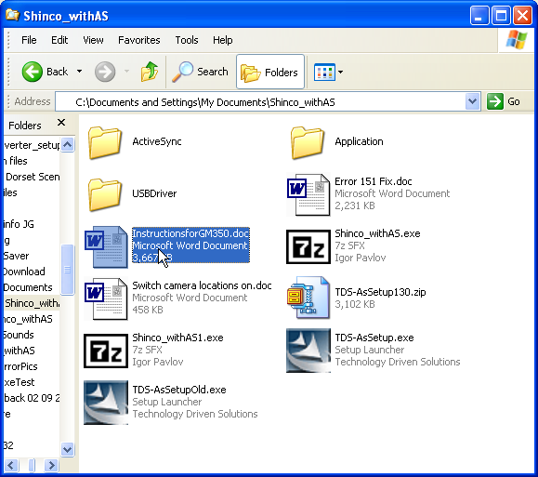
Double Click on the highlighted instruction file to continue

The file name is “InstructionsforGM350”

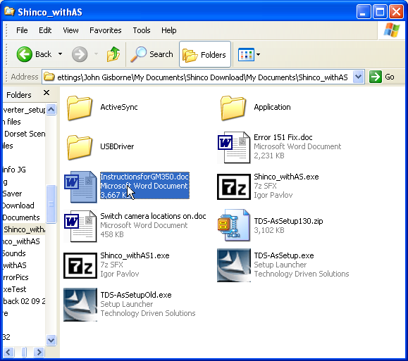

Work your way through the instructions to install the software.

DO NOT miss ANY steps, if you do the installation will fail and you will not get any camera alerts.

TDS 09/04/2010

