To install the TR30 in Windows Vista & “7” 32 & 64 bit ALL VERSIONS.

Section 1 Uninstalling Device
If the TR30 has been connected previously then you need to uninstall it from your system, if the TR30 has NOT been connected you may skip this part & move on to the Driver download and installation section below.

To Uninstall the TR30, CONNECT THE TR30 (TRXX Device) TO YOUR PC, open your control panel, locate “Device Manager”
- Click on the Start button and then choose Control Panel.
- Click on the System and Security link.
Note: If you're viewing the Large icons or Small icons view of Control Panel, you won't see this link. Simply click on Device Manager and then proceed to Step 4.
- In the System and Security window, click on the Device Manager link located under the System heading.
- You can now use Device Manager to update device drivers, view the system resources that a hardware device is using, etc.
Look in the Device manager window for TRXX Device it will probably have either a cross or exclamation mark next to it.

Note: The supplied image does not have a cross or exclamation mark because it was taken from a computer where the TR30 driver is correctly installed

2. Uninstall the driver for the TR30 (TRXX Device)

Device Manager in Vista 32 Bit, other versions may look different
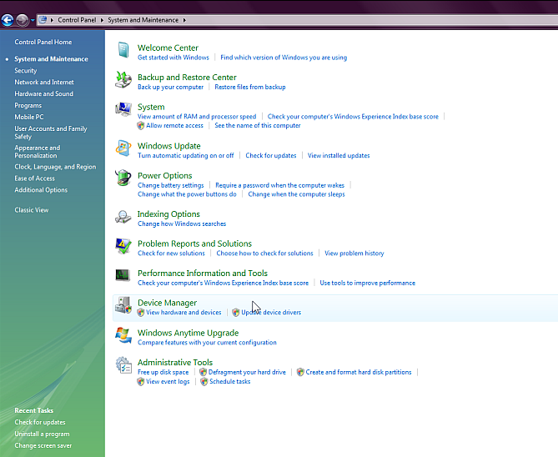

Right click on TRXX Serial Port
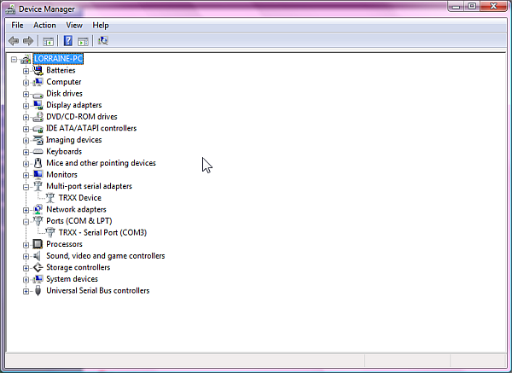

Click on Uninstall
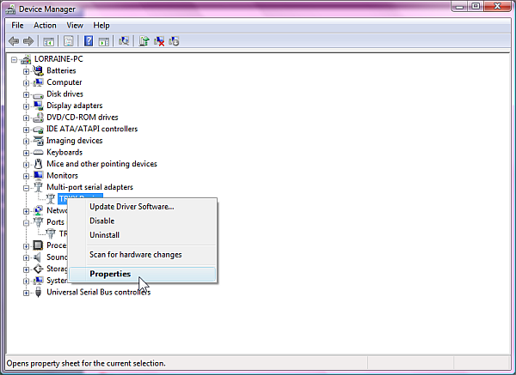

Look for TRXX Device in the Device Manager window above, RIGHT CLICK ON IT
You will see a menu appear, look for “Properties” An alternative way to uninstall the driver is as follows, which way you do it depends on your version of Windows.
Left click on Properties
Look for the tab at the top of the device properties window for Driver
Click on the Driver tab
Near the bottom of the device properties window you will see the Uninstall Driver
Click on it to uninstall the driver

DISCONNECT THE TR30 (TRXX Device) AT THIS POINT

Proceed to section 2

Section 2 Downloading & Installing the driver file

Download the driver file from our website http://www.tds-tr.com/tds2/html/supportdl.htm
Look for the following text: Download TRxx Driver Package v2.1 07/06/2012 8.33MB
Click on v2.1

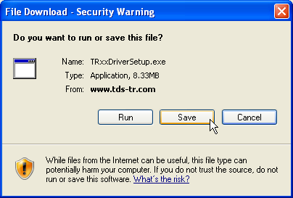

Save to My Documents or a folder where you KNOW you can find it again.
Note: DO NOT SAVE TO YOUR DESKTOP
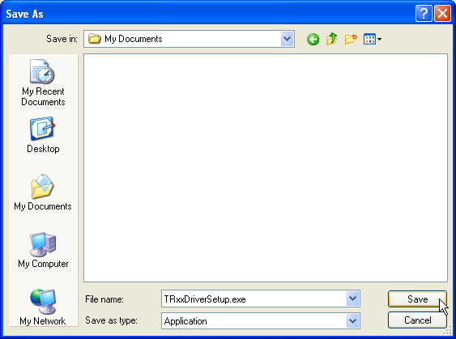
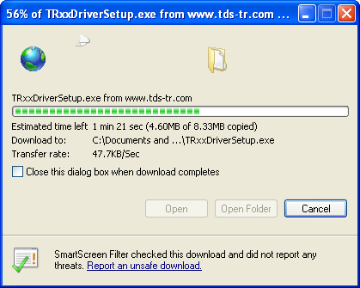

When the file has finished downloading click “Open Folder” and find the fill named
TRxxDriverSetup

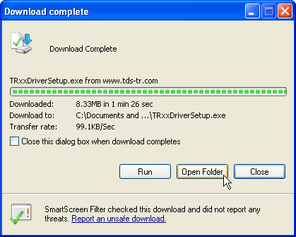

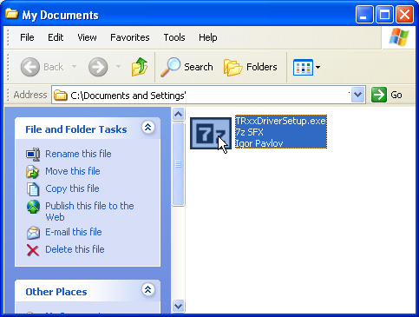
Double click on TRxxDriverSetup to run it and unpack it to your my Documents folder

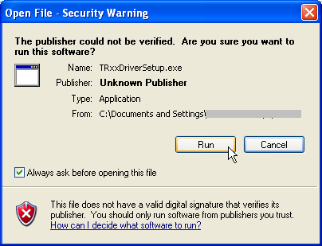

Click Run, if you do not click Run it will not work.
NOTE: Depending on your version of Windows you MAY not see the Open File – Security Warning
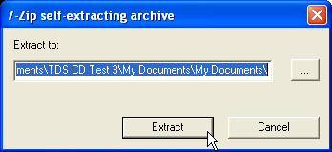
Click on Extract, this will unpack the files needed to install the driver for the TR30 (TRXX Device)

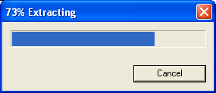

When the files have finished extracting go back to you’re my Documents folder DOUBLE click on the file named Driversetup

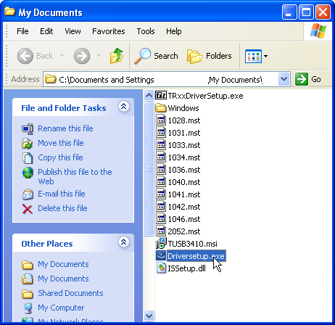

This will install the driver package on your computer; you MUST accept the license agreement or the driver installation process will not work.

Click Finish when the installation is complete.

The Driver package is now installed on your computer.

CONNECT THE TR30 TO YOUR COMPUTER NOW

The TR30 driver install wizard will start, accept any requests to install, or authorisations,

Note: if you do not accept or authorise, the driver installation will fail and the TR30
will not update.

You should then see a message stating “Your hardware is now ready to use”.

This concludes the TR30 (TRXX Device) Driver installation process

Note: Depending on your version of Windows you MAY need to restart your
computer.

On the downloads page of the website www.tds-gb.com you will find the CD Install
Program, all you need to do is click on the link and run it from the website

This will install the TDS Update utility including the critical update on to your PC.

When this is complete you will see the TR Series Update Utility on your desktop, double click on it to start the program

TR Series Update Utility Icon
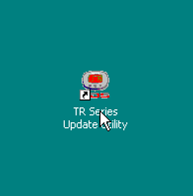

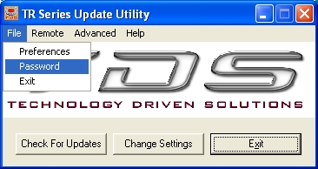
Click on File then password, click in the empty password box & enter your password

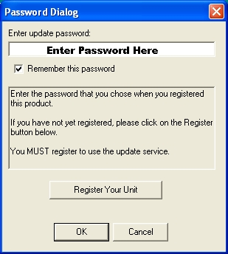
Enter the password you gave us on the registration page & tick Remember Password
Click on OK

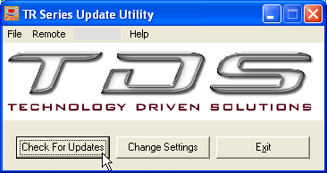
Click on check for updates, you will see the sequence on the following page.

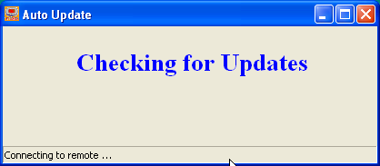

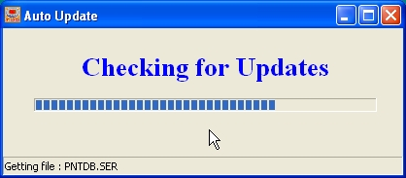

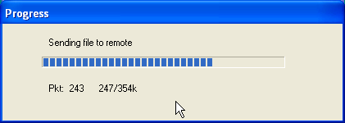

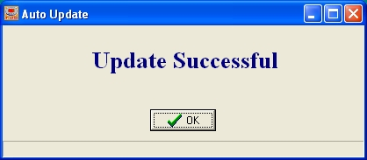

When you have clicked on check for updates and seen update successful your TR30 will have the latest camera database.

This concludes the software installation process, all that needs to be said now is UPDATE ONCE A WEEK !!!!! The TR30 is only as good as when you last updated it
We update our camera database most working days, you should update once a week to keep up with the ever changing camera situation in the UK.

Regards

TDS Customer Support

