How to download and install your Shinco
GM350software


DO NOT CONNECT THE GM350 UNTIL THE INSTRUCTIONS TELL YOU TO

IMPORTANT READ AND FOLLOW ALL STEPS IN ORDER
NO CD IS REQUIRED

This section deals with downloading and saving the Shinco software in the correct location in your computer.

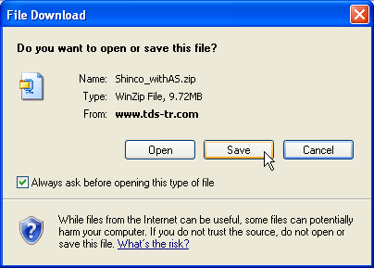

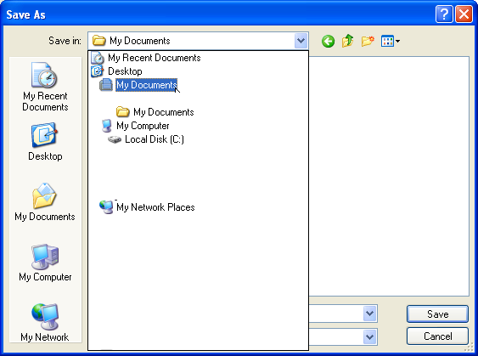

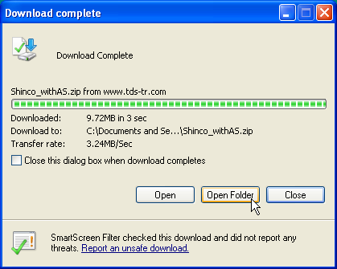

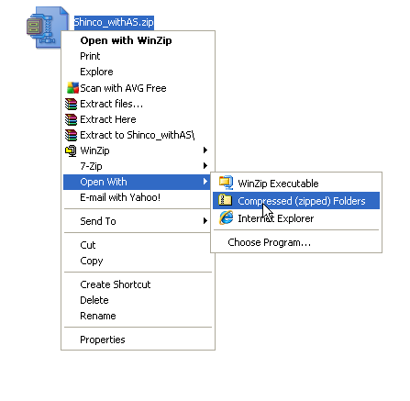

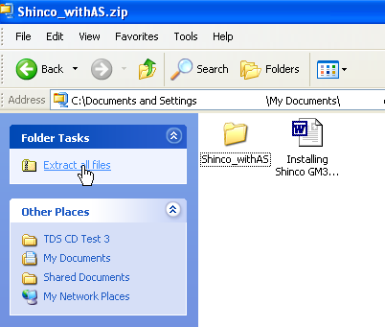

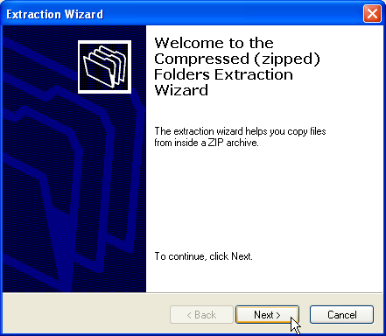

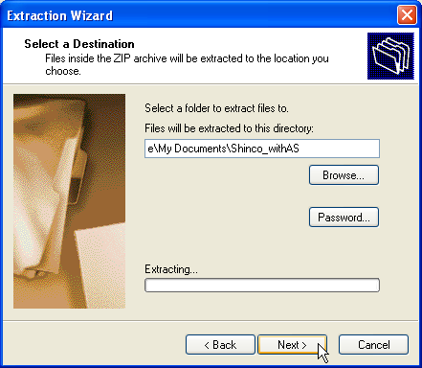

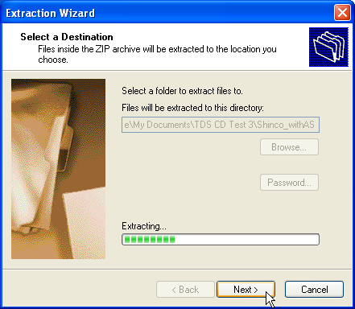

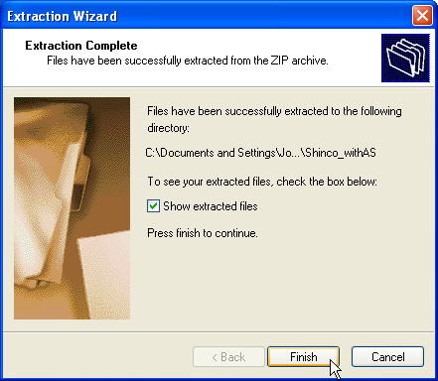

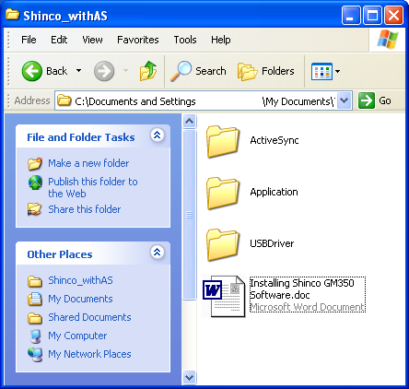

Installing the USB Driver, Now you get to connect the Nav to your computer
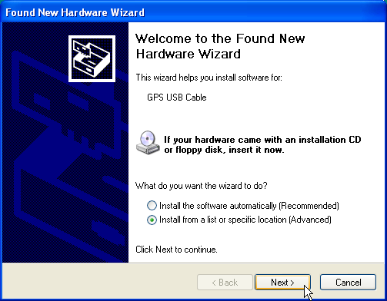

Tick box that says “Include this location in search”
Then click on “Browse”
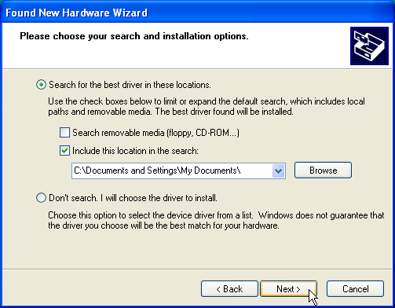

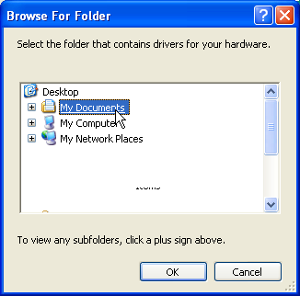

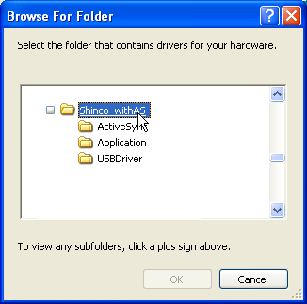

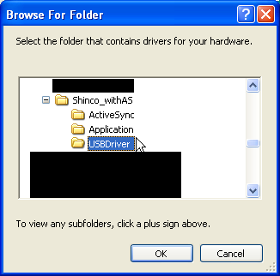

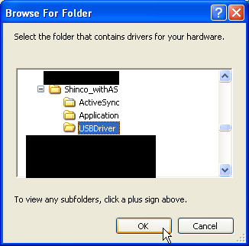

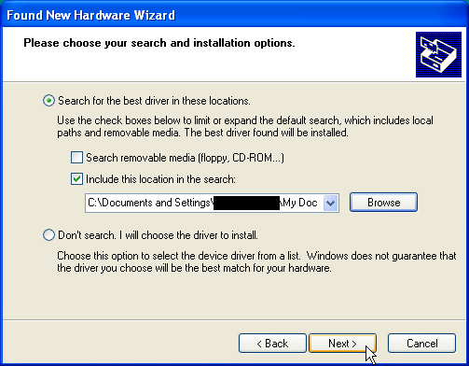

Click Continue Anyway, Note: if you click Stop the GM350 will not work
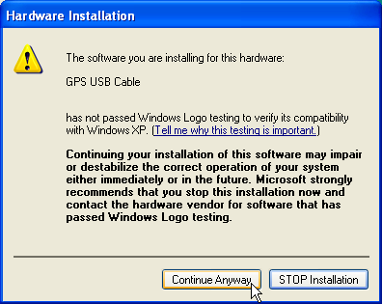

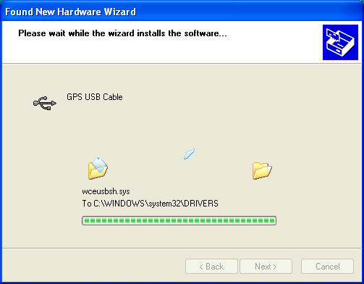

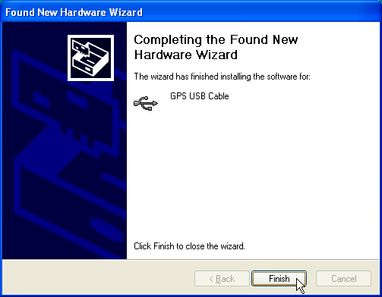

This concludes the installation of the USB Driver

Now to install Active Sync

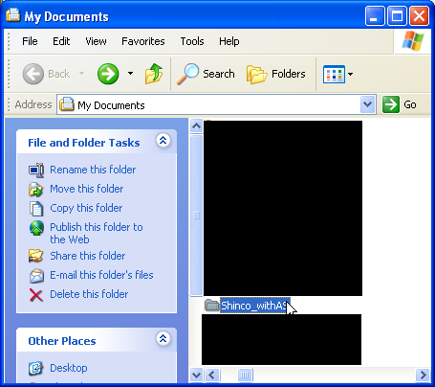

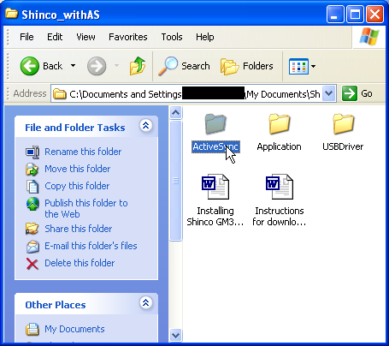
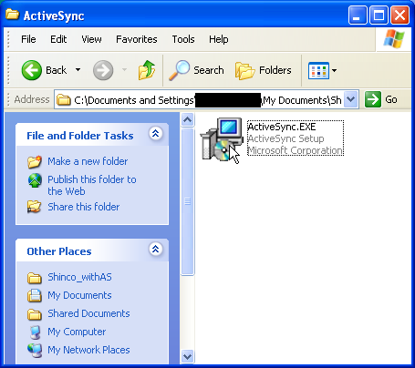

Double click on this Icon to start Active Sync installation

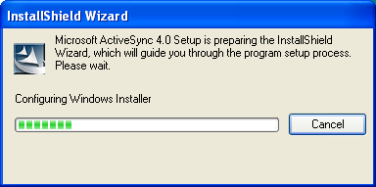

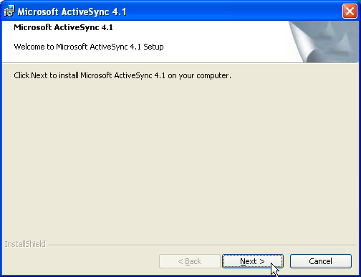

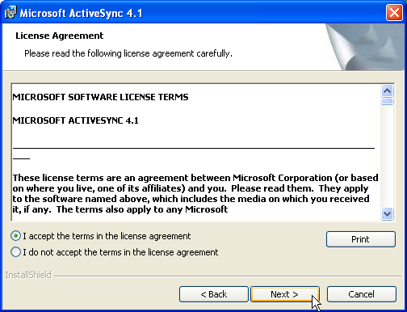

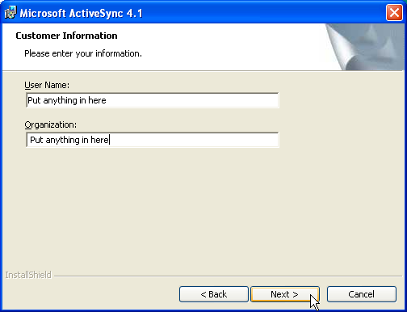

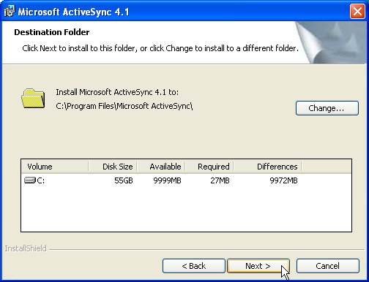

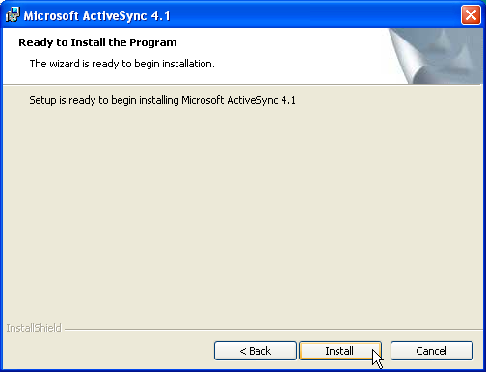

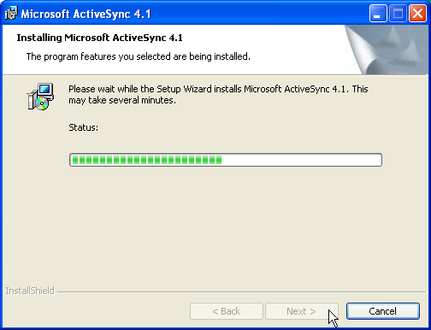

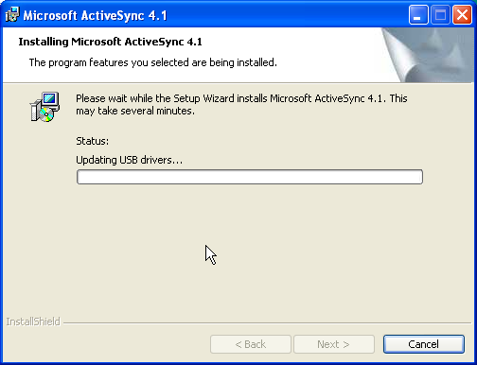

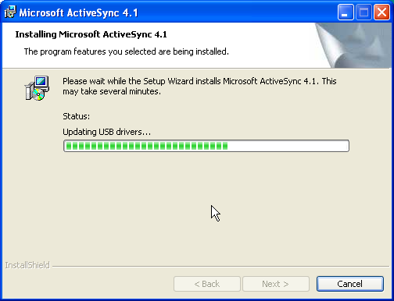

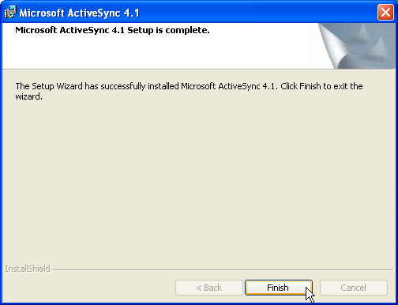

Click finish to conclude the installation of Active Sync, at this point you May need to re-start your computer

When you have re-started your computer you are nearly ready to go

Make sure the battery in the sat nav is FULLY charged, switch on the sat nav, you will see Active Sync appear, (Vista & Windows 7 users will see a different application)

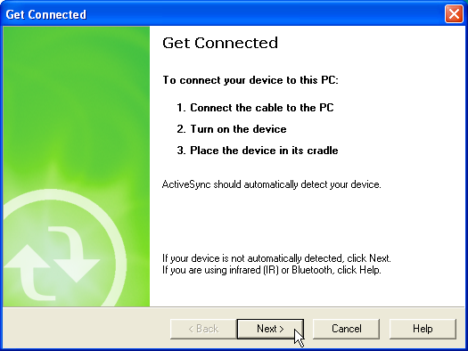
Depending on your version of Windows these screens may differ.
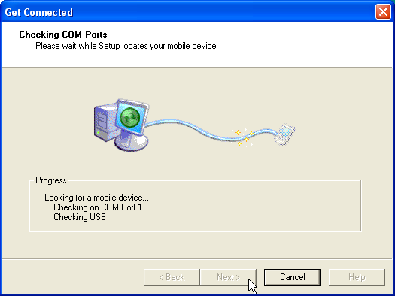

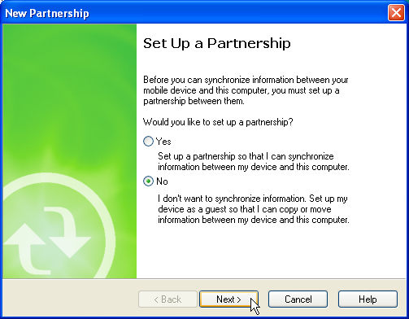
ALWAYS CLICK ON NO & NEXT
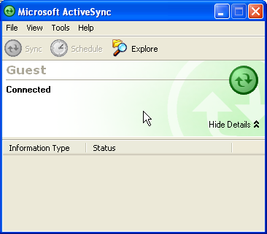

That concludes the installation of active Sync, as you will see your nav is now connected to your computer. When you have installed the update utility and Error 151 patch in the next section your nav will be ready to receive the camera updates.

Now to install the TDS update utility

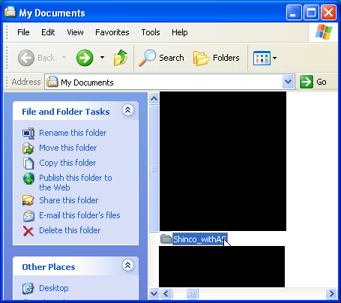

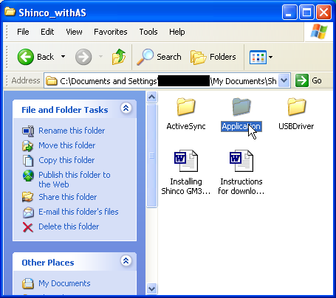
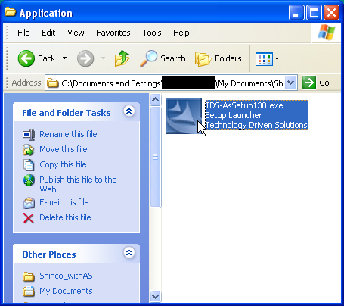

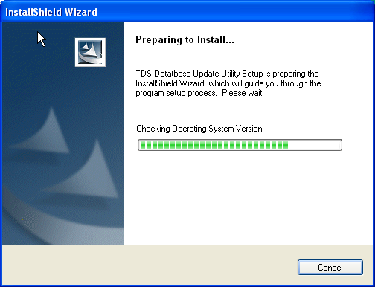

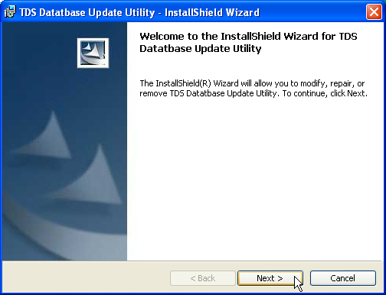

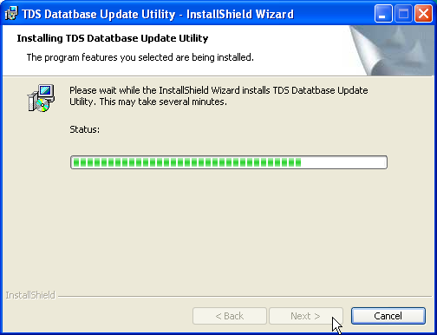

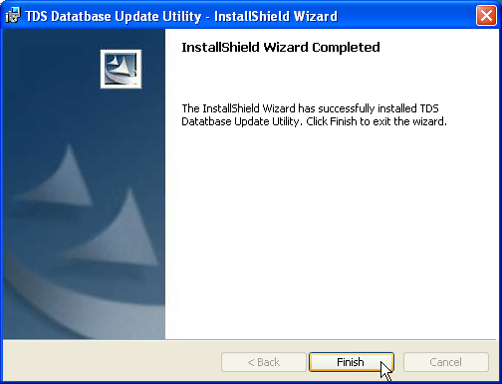

This is the sequence to follow when carrying out the patch install for Error 151

Note: This is NOT an optional software update, in short if you do not update the software it will not work and you will see Error 151.

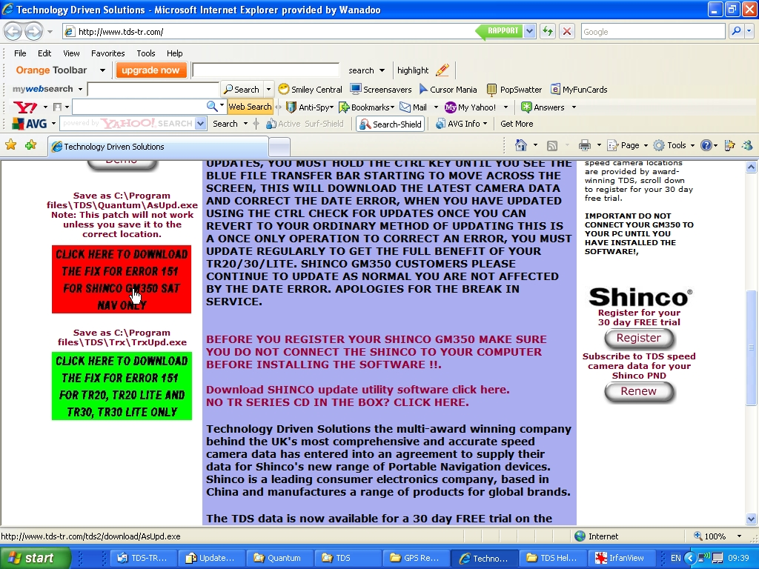

Click on the RED panel on the front page of our website
www.tds-gb.com

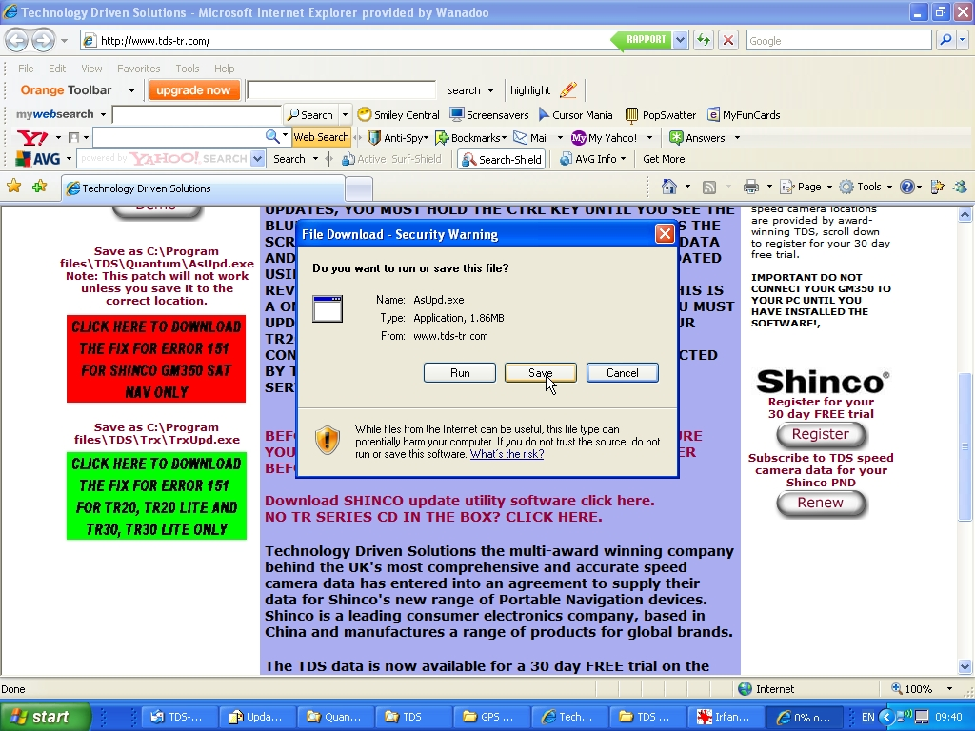

Click on Save, a window will open to ask you where you want to save the file to, you MUST save the file as per the instructions or it will not fix the error 151 problem.

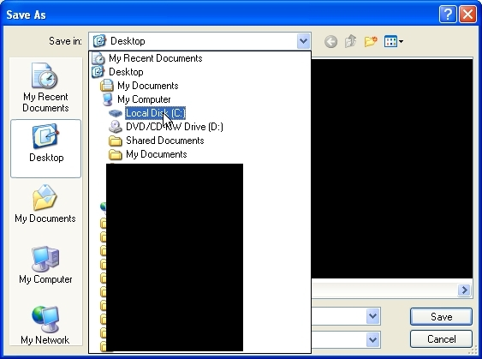
Double click on Local Disk C:
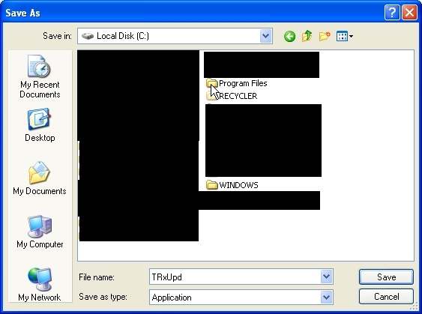
Double click on Program Files
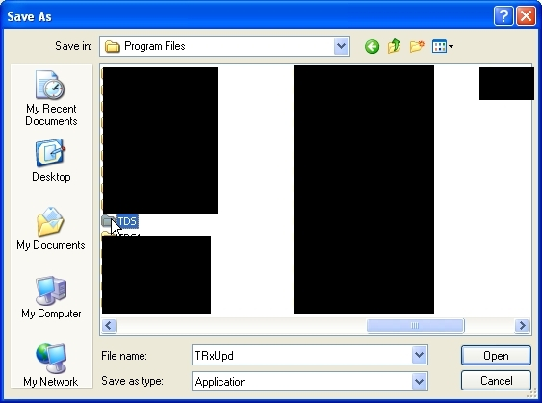
Double Click on TDS
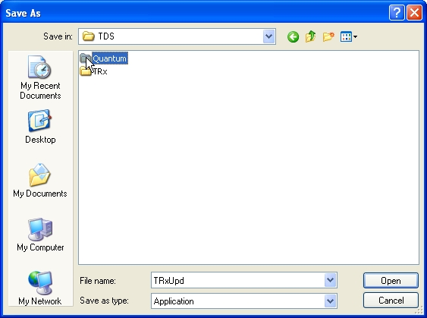
Double click on Quantum
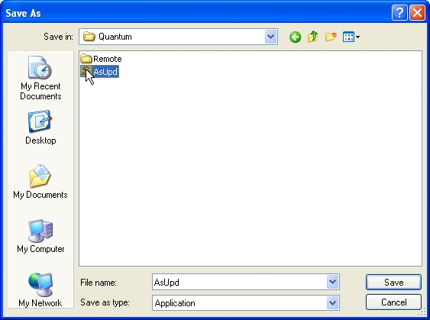
SINGLE CLICK on AsUpd
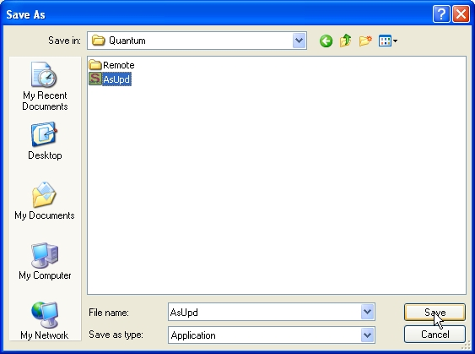
Click on Save

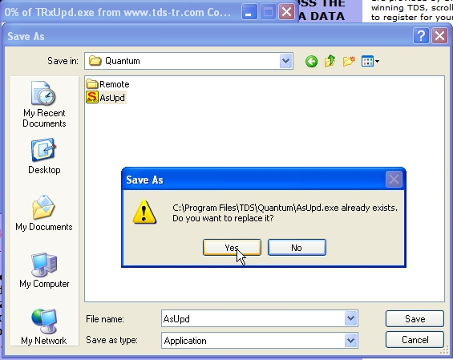
Click on Yes

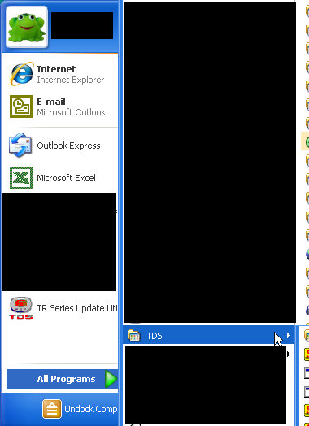

Go to all programs look for TDS put your mouse over TDS it will open up to show you the update utility TDS Database update, In the next part of the instructions you will need to click on it to start the program to update the camera locations.

Programming the serial number and updating the camera locations.

Now you can open up the TDS Update utility, click on your START menu, look for all programs, hover your mouse over all programs, look for TDS, hover over TDS, look for TDS Database Update, click on it and the program will open.
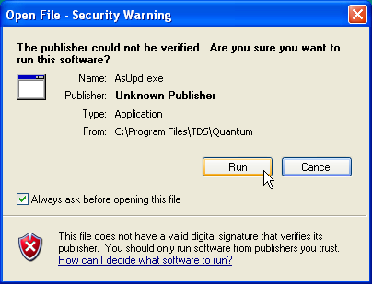

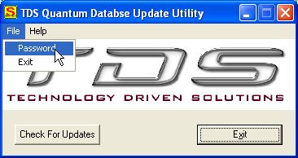

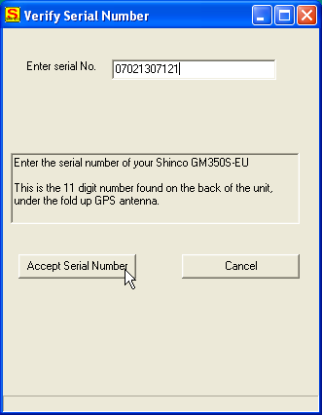
The serial number shown here is an example, do not enter it, enter your own 11 digit number, this will be found under the antenna flap as shown in the picture below

NOTE: If you have a serial number starting with A111 or A112 entered in the box “Remote Serial Number” already you MUST contact support@tds-gb.com with that A11 number and the serial number on the back of the nav under the antenna flap. We will change the number at our end. When we have changed the number you can update your nav.
. 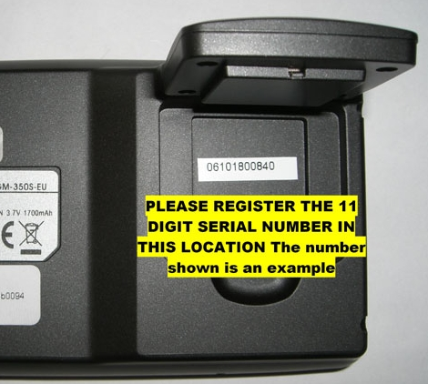

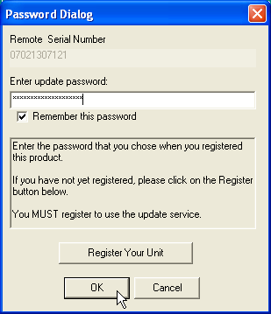
Click on Ok
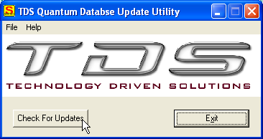
Click Check for Updates
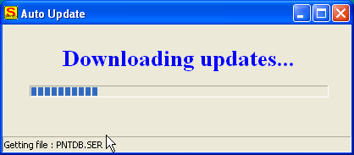

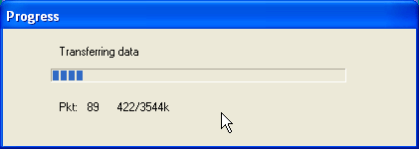

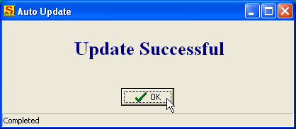

This completes the update sequence; all that remains to be done is to switch on the camera locations,
NOTE: if you do not switch on the camera locations you will not get any camera alerts.
The following sequence will allow you to switch on the camera alerts.
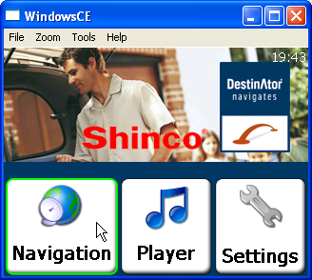
Click on Navigation
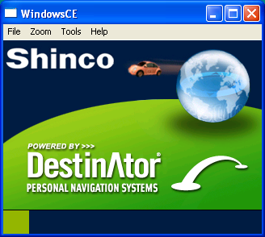
Destinator startup screen shows
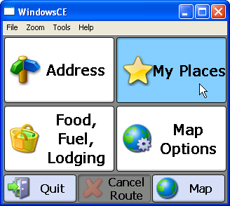
Click on My Places
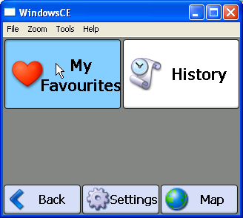
Click on My Favourites

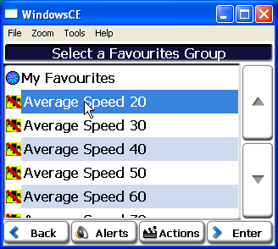
Click ONCE on Average Speed 20

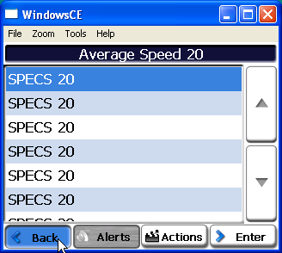
NOTE: If you see this on your nav’s display you have clicked one too many times, just use the Back button to get back to the screen above and continue

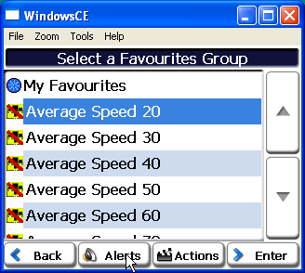
Click on Alerts
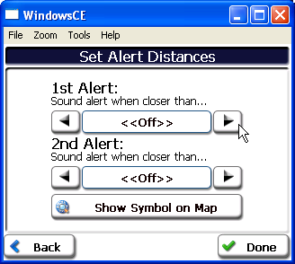
Click on the RIGHT hand arrow to select the 1st Alert distance, this MUST be 550 Yards

Use the RIGHT hand button to set the SECOND alert, this MUST be 110 Yards
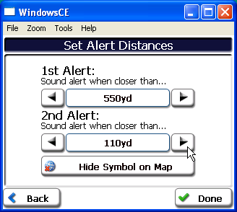
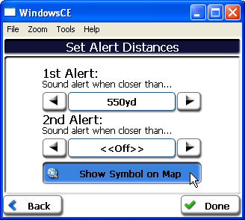
Click “Show Symbol on Map” this will turn into “Hide symbol on Map” this is CORRECT, the alert is NOW enabled.
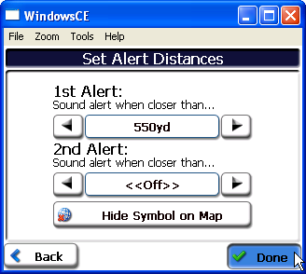
Click on Done
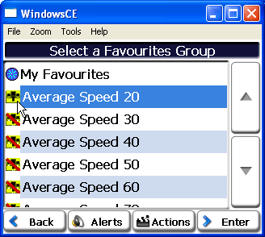

Note: There are 20 YES 20!! of these alerts to switch on, you MAY decide not to have Congestion Charge alerts on or Toll Road alerts on but you MUST at least have ALL of the speed camera alerts switched on or you will NOT get ANY camera alerts

Note in the above picture there is NO RED BAR across Average speed 20 this means it is switched on, there are Red bars across ALL of the other alerts, this means they are SWITCHED OFF and MUST be switched on to give an alert.

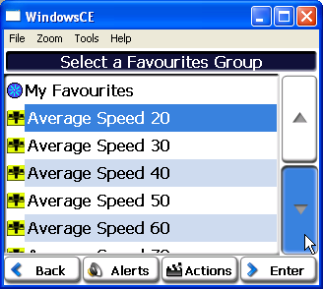
Use the scroll button to scroll down to find all of the alerts

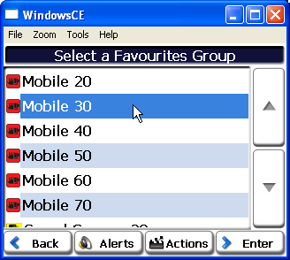
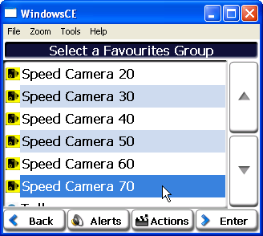
Note NONE of these alerts have red bars across them, this means they are SWITCHED ON and will give alerts when required.
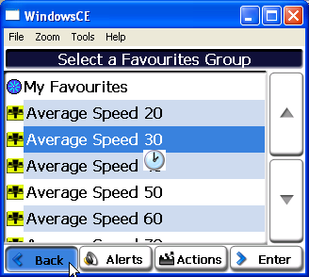
Click Back
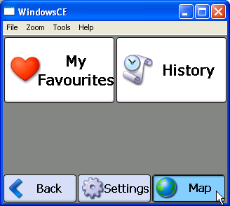
Click on Map to operate nav.

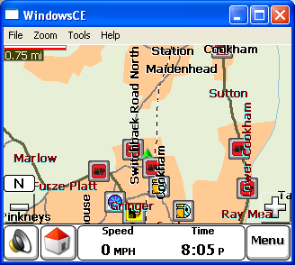
An example of the speed camera location map, depending on your zoom level your map MAY look different.

This completes the GM350 setup, you MUST MUST MUST update at the VERY LEAST every 30 days or you will loose camera alerts and have to go through the steps of switching them back on again, you SHOULD be updating every week.

Regards
TDS Customer Support

